
ARTI406: Machine learning
assignment 2
Student Name: Zainab Habib Al Sadiq
Student ID: 2230002911
Dataset: Sleep Health and Lifestyle Dataset

Task 1: Identify Data Quality Issues
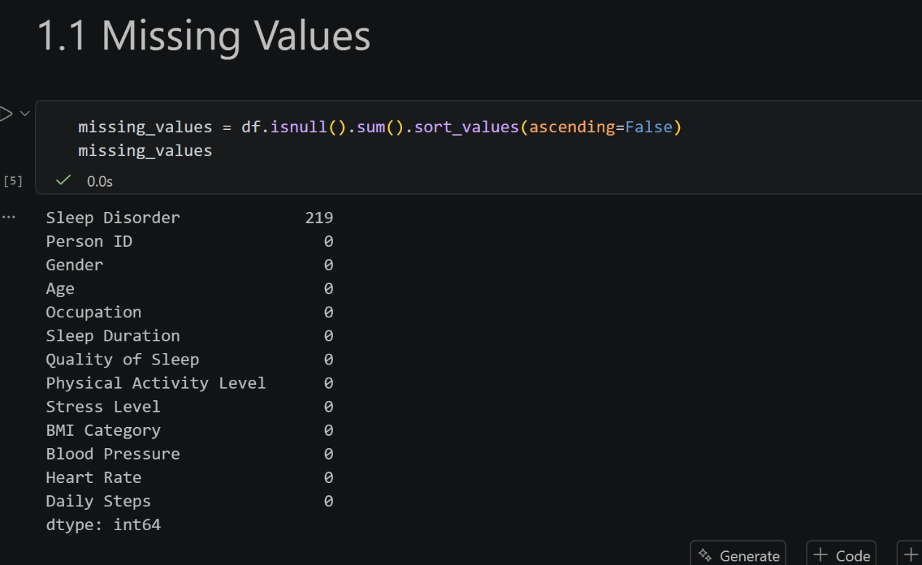The dataset was checked for missing values.

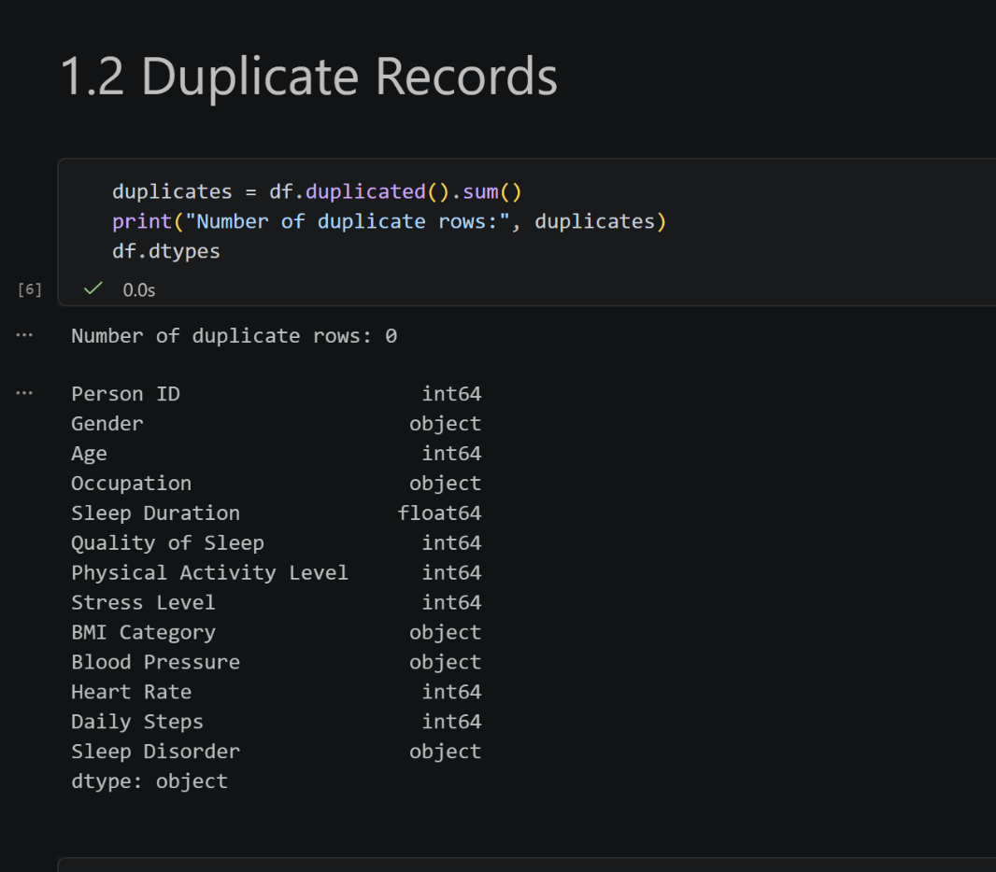
No duplicate records were found in the dataset

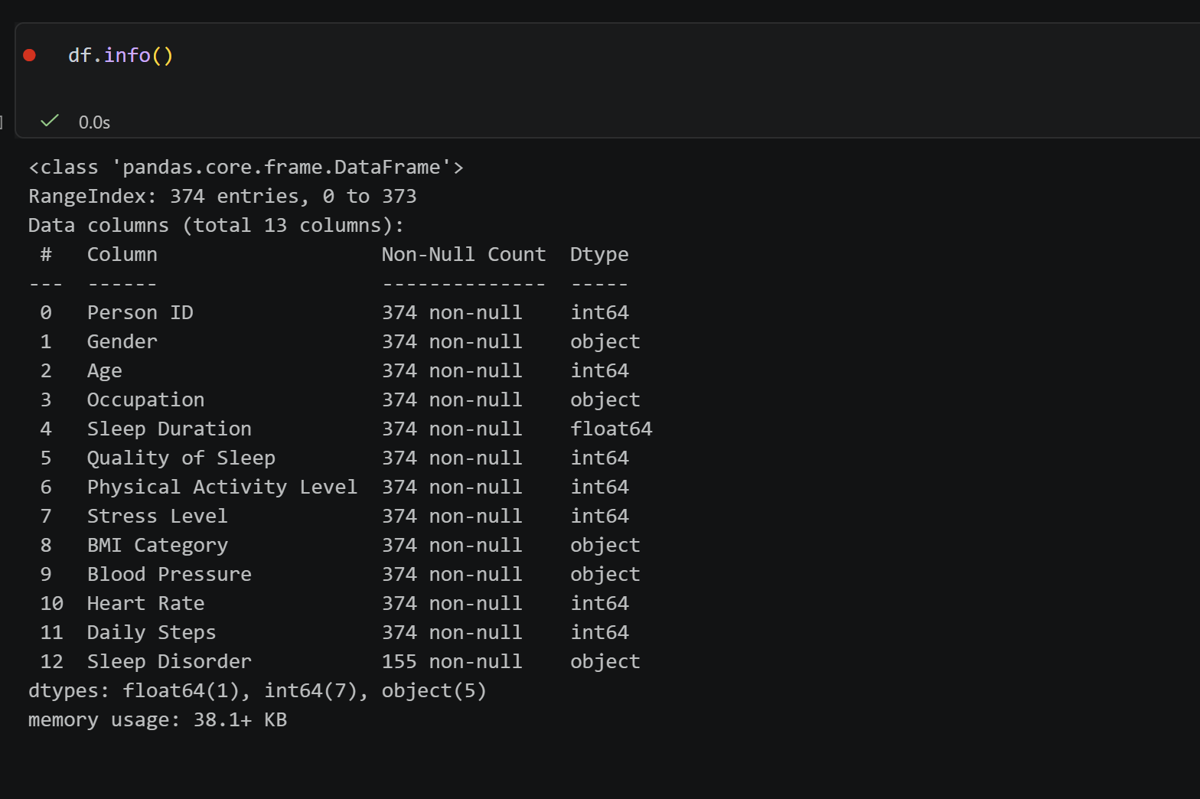
Task 2: Missing Value Strategy
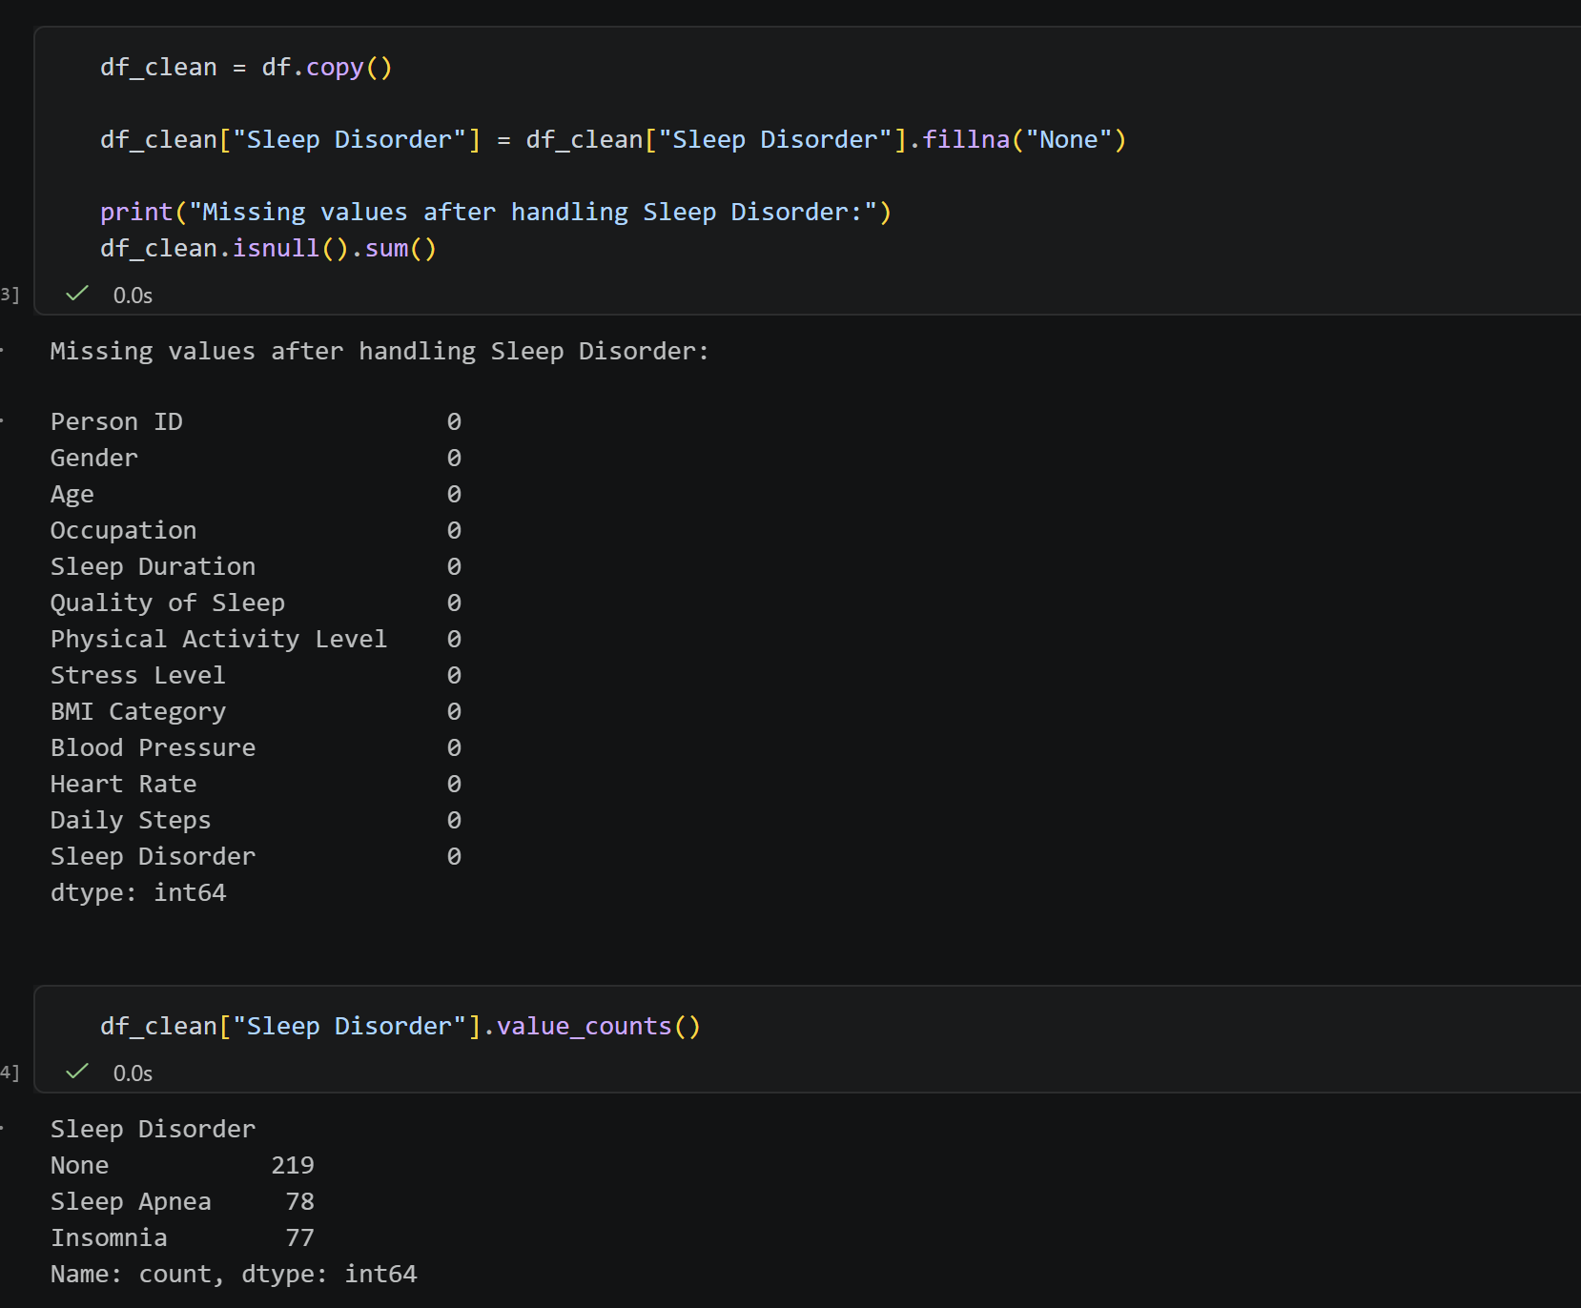
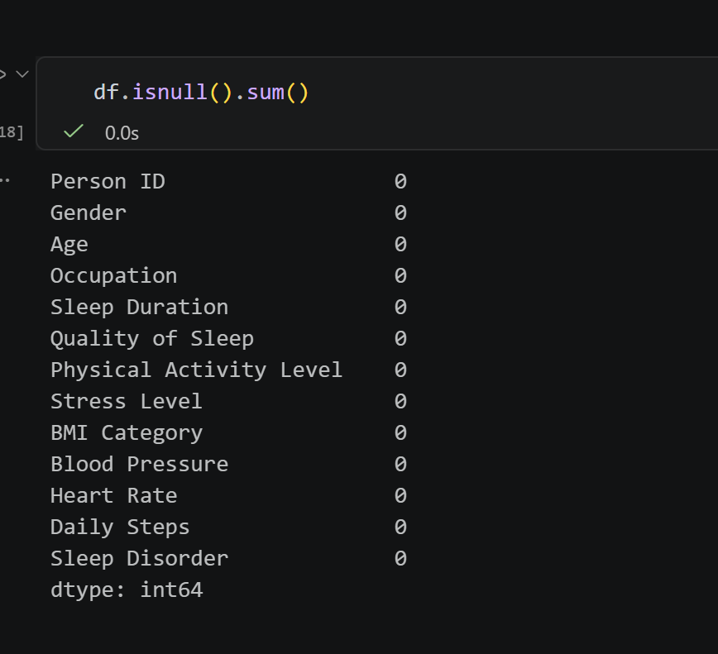
Missing values were replaced with "None" because missing entries indicate that the individual does not suffer from a sleep disorder.

Task 3: Outlier Detection and Handling Using IQR
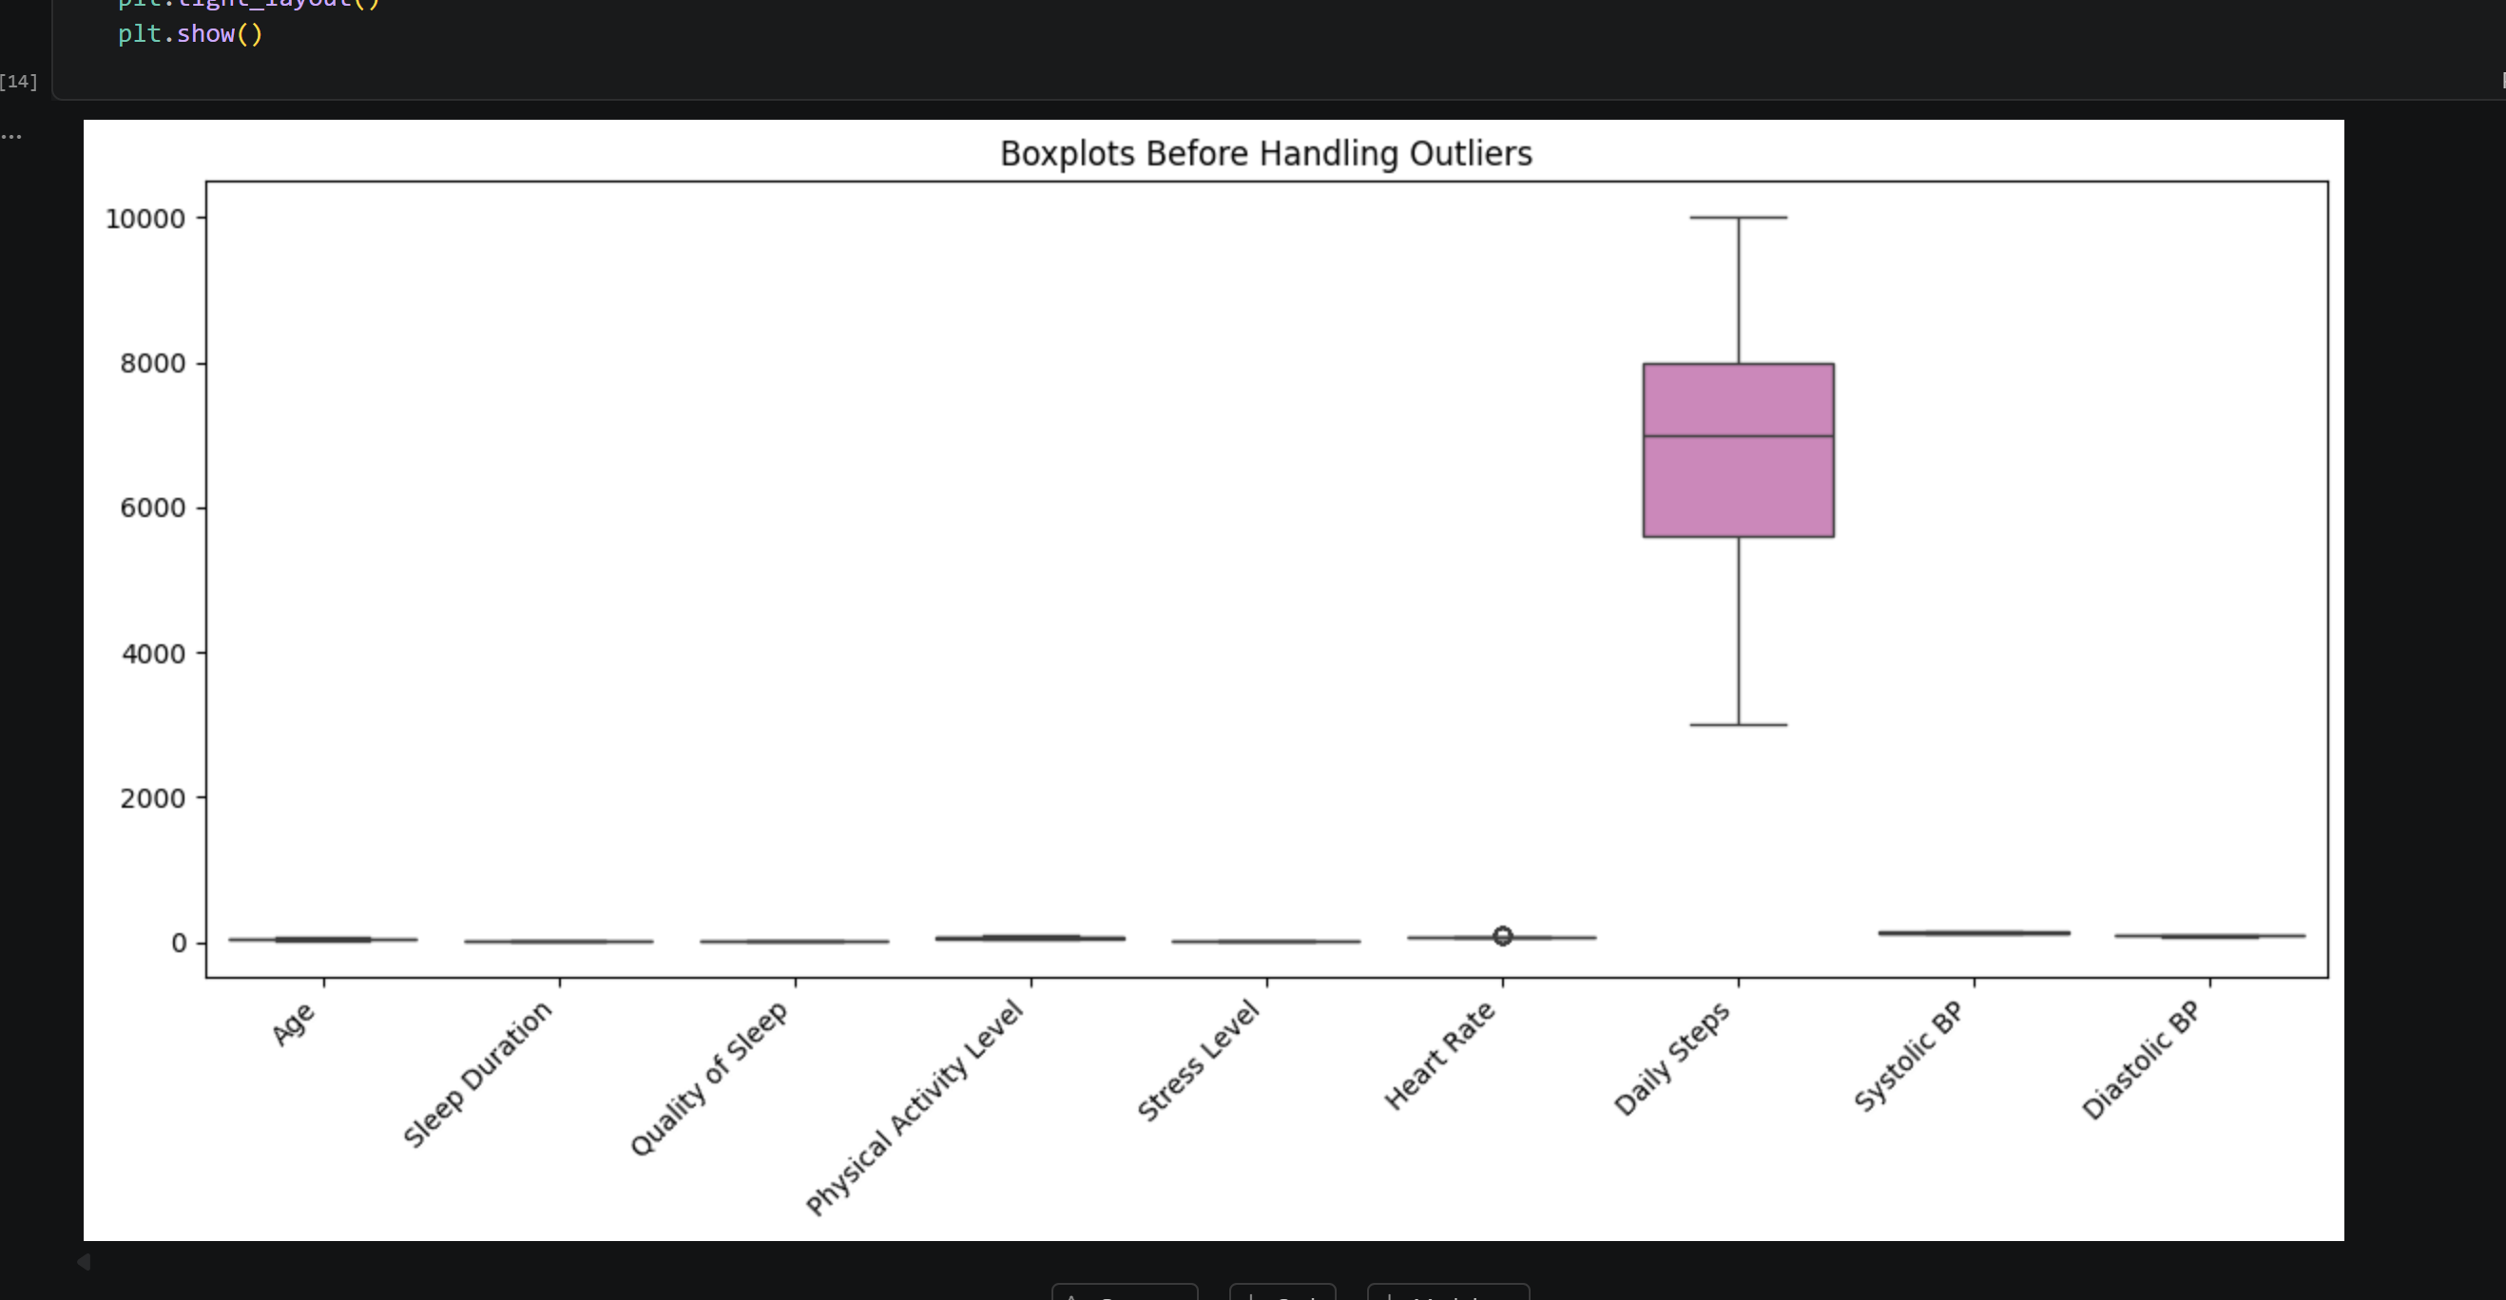

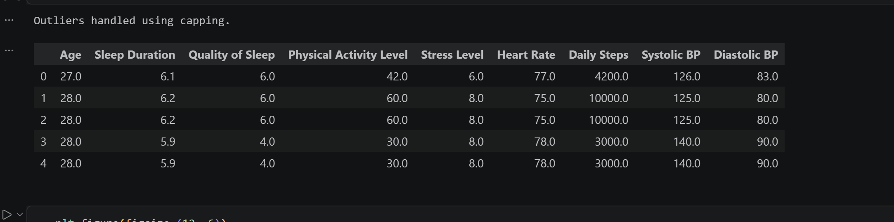
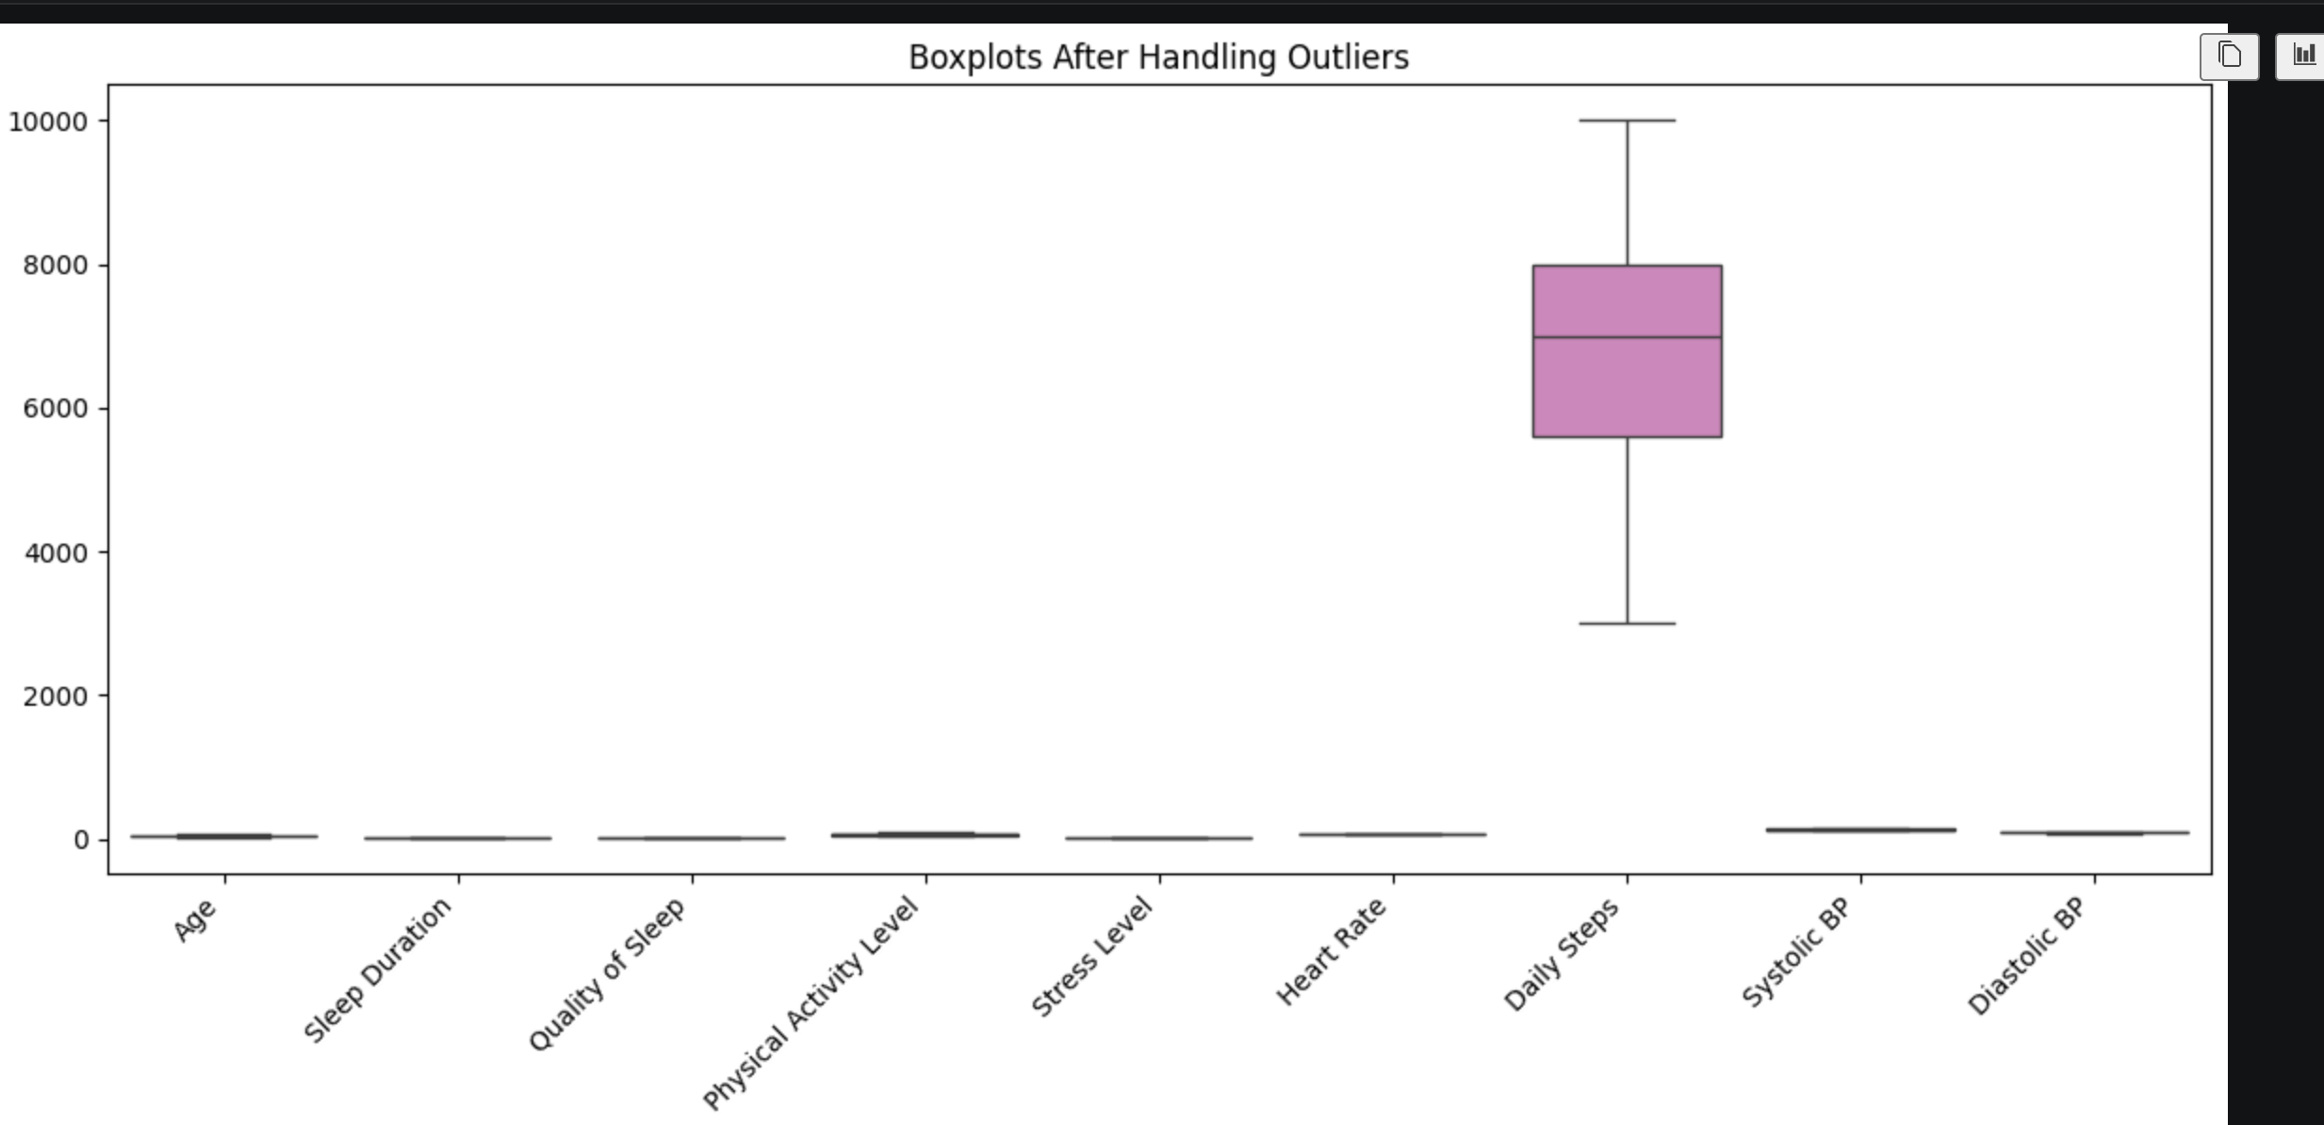
Outliers were detected using the IQR method and handled using capping.

Task 4: Normalization
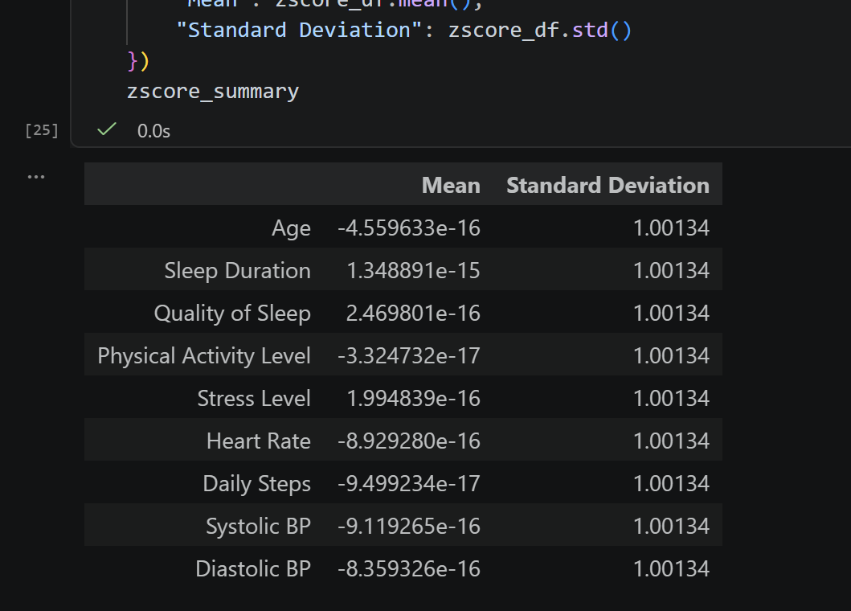
Task 5: Principal Component Analysis (PCA)
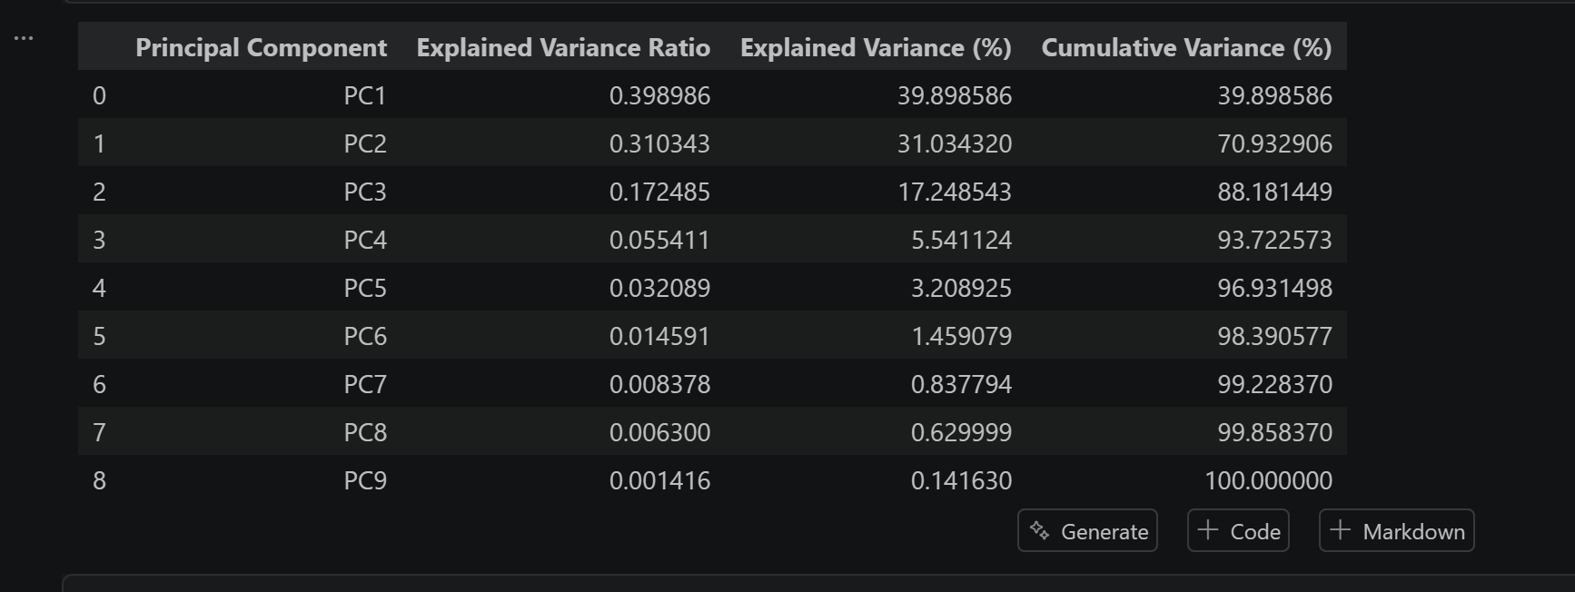
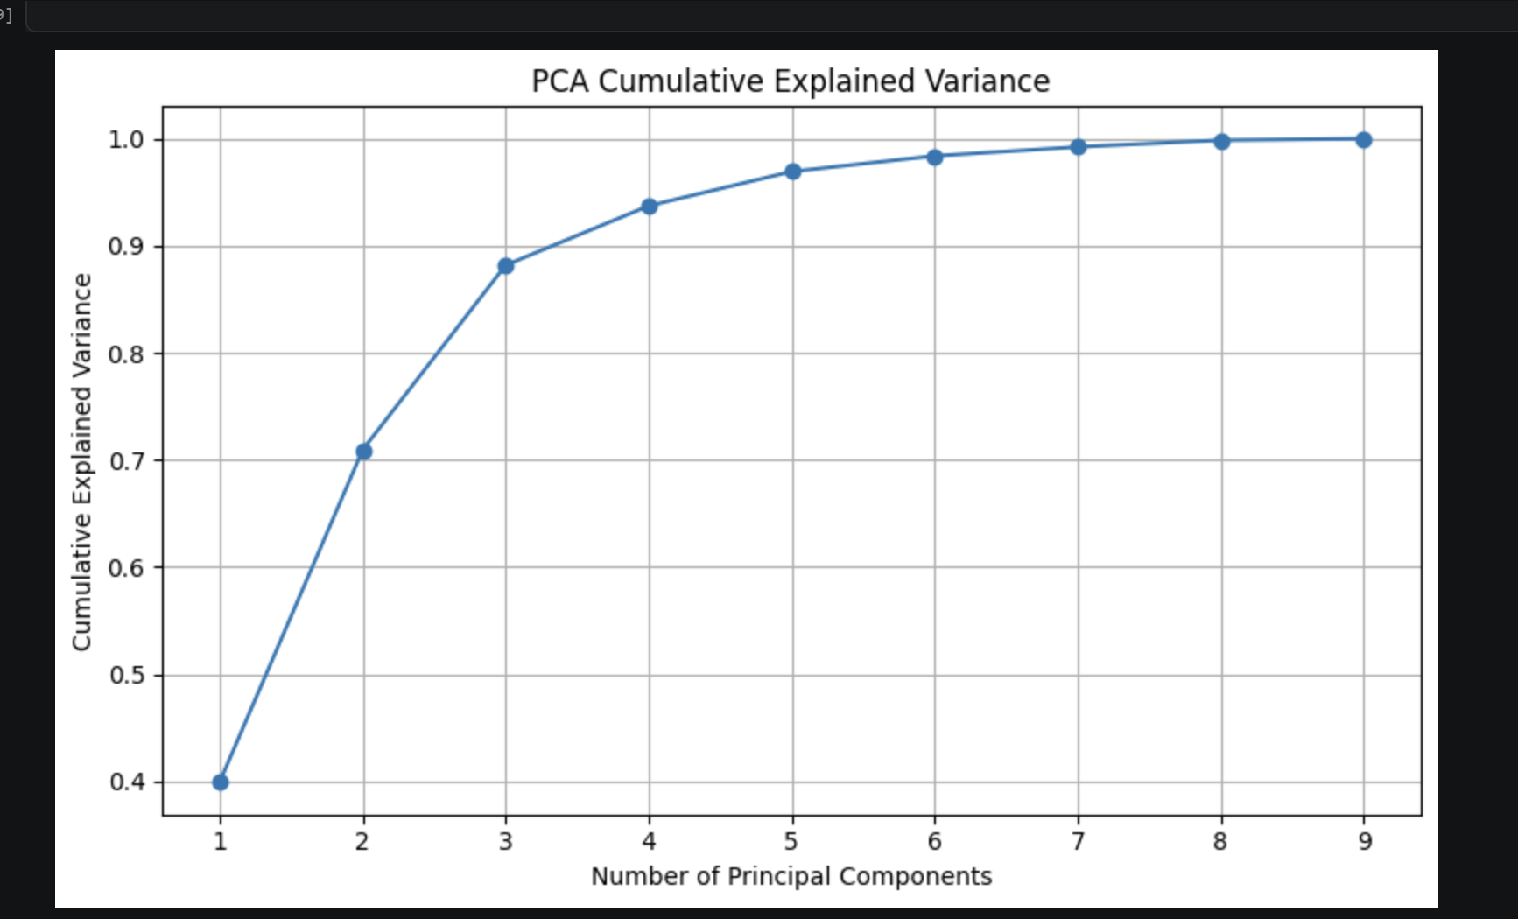
The first principal components explain most of the variance in the dataset. Therefore, PCA can reduce dimensionality while preserving most of the information.
Finally, the dataset was analyzed and preprocessed successfully. Missing values were handled, outliers were detected and treated using IQR, numerical features were normalized using Min-Max and Z-score methods, and PCA was applied to reduce dimensionality while retaining most of the dataset information.

